**HOME AUTOMATION USING ARDUINO UNO**

**A Project Report**

Submitted in partial fulfillment of the

Requirements for the award of the Degree of

**BACHELOR OF SCIENCE (COMPUTER SCIENCE)**

**By**

Mohini Bharambe

Seat Number

**Under the esteemed guidance of**

**Miss Nidhi N. Patel**

**Assistant Professor**



**DEPARTMENT OF COMPUTER SCIENCE**

**SMT. DEVKIBA MOHANSINHJI CHAUHAN COLLEGE OF COMMERCE AND SCIENCE**

*(Affiliated to University of Mumbai)*

**SILVASSA, 396230**

**DADRA & NAGAR HAVELI**

**2020-21**

**ACKNOWLEDGEMENT**

First and foremost, I would like to take this opportunity to thank our lecturer Miss Nidhi N. Patel for her guidance and constant supervision as well as for providing necessary information regarding this project and also for their support in completing the project.

I am very grateful to our College, lecturer where they gave us enough of time to complete this project and at the same time I would like to thank to my classmates who helps me allot to complete this project.

Thank you.

**DECLARATION**

I hereby declare that the project entitled, “**Home Automation Using Arduino UNO**” done at **Smt. Devkiba Mohansinhji Chauhan College of Commerce and Science**, has not been in any case duplicated to submit to any other university for the award of any degree. To the best of my knowledge other than me, no one has submitted to any other university.

The project is done in partial fulfillment of the requirements for the award of degree of **BACHELOR OF SCIENCE (COMPUTER SCIENCE)** to be submitted as final semester project as part of our curriculum.

**Name and Signature of the Student**

Mohini Bharambe

**ABSTRACT**

The main objective of this project is to develop a home automation system using an Arduino board with Bluetooth being remotely controlled by any Android OS Smartphone. As technology is advancing so houses are also getting smarter. Modern houses are gradually shifting from conventional switches to centralized control system, involving remote controlled switches. Presently, conventional wall switches located in different parts of house make it difficult for the user to go near them to operate. Even more it becomes more difficult for the elderly or physically handicapped people to do so. Remote controlled Home Automation system provides a most modern solution with smart phone.

In order to achieve this, a Bluetooth Module is interfaced to the Arduino board at the receiver end while on the transmitter end, a GUI application on the cell phone sends ON/OFF commands to the receiver where loads are connected. By touching the specified location on the GUI, the loads can be turns ON/OFF remotely through this technology. The loads are operated by Arduino board through opt-isolators and thyristors and traics.

**TABLE OF CONTENTS**

**S.NO. PERTICULERS**

Acknowledgement

Declaration

Abstract

**Chapter 1: Introduction**

* 1. Project Aim
  2. Project Objectives
  3. Project Purpose, Scope and Limitations
  4. Description of the Project

**Chapter 2: System Analysis**

* 1. Hardware Requirement
  2. Software Requirement

**Chapter 3: Description of Hardware Requirement**

**3.1 Arduino UNO**

3.1.1 Hardware

3.1.2 Pin Description

3.1.3 Communication

**3.2 HC-05 Bluetooth Module**

3.2.1 Use the HC-05 Bluetooth

3.2.2 Bluetooth module circuit connection

3.2.3 Application

3.2.4 Bluetooth Interfacing with ARDUINO UNO

**3.3 4-Channel Relay Module**

3.3.1 Understanding of 5V 4-Channel Relay Module

3.3.2 Use of 4-Channel Relay Module

3.3.3 Pin Description

3.3.4 Features

**Chapter 4: Implementation**

4.1 Coding

4.2 Design and Implementation

**Chapter 5: Pros & Cons of Home Automation**

**Chapter 6: Application of this project**

**Chapter 7: Conclusion**

**Chapter1**

**Introduction**

Nowadays, we have remote controls for our television sets and other electronic systems, which have made our lives real easy. Have you ever wondered about home automation which would give the facility of controlling tube lights, fans and other electrical appliances at home using a remote control? Off-course, Yes! But, are the available options cost-effective? If the answer is No, we have found a solution to it. We have come up with a new system called Arduino based Home Automation using Bluetooth. This system is super-cost effective and can give the user, the ability to control any electronic device without even spending for a remote control. This project helps the user to control all the electronic devices using his\her Smartphone. Time is a very valuable thing. Everybody wants to save time as much as they can. New technologies are being introduced to save our time. To save people’s time we are introducing Home Automation system using Bluetooth. With the help of this system you can control your home appliances from your mobile phone. You can turn on/off your home appliances within the range of Bluetooth.

* 1. **Project Aim**

The aim of the project is to design and construct a home automation system that will remotely switch on or off any household appliances connected to it. Using a microcontroller, voice dial or phone, or Bluetooth based android application.

* 1. **Project Objective**

The objective of this project is to implement a low cost, reliable and scalable home automation system that can be used to remotely switch on or off any household appliances, using a microcontroller to achieve hardware simplicity, low cost short messaging service for feedback and voice dial from any phone to toggle the switch state.

* 1. **Project Purpose, Scope and Limitation**

The benefits of home automation typically fall into a few categories, including savings, safety, convenience, and control. Additionally, some consumers purchase homeautomation for comfort and peace of mind. This project work is to complete on its own in remotely and automatically switching on or off of an electrical appliance not limited to household appliances and sends a feedback message indicating the new present state of the appliances.

* 1. **Description of the Project**

This project is one of the important Arduino Project. Arduino based home automation using Bluetooth project helps the user to control any electronic device using Device Control App on their Android Smartphone. The android app sends commands to the controller- Arduino, through wireless communication, namely, Bluetooth. The Arduino is connected to the main PCB which have Four relays as shown in the Block Diagram. These relays can be connected to different electronic devices. As per the block diagram, Device 1- Buzzer, Device 2- Fan, Device 3- Lights. When the user presses on the ‘On’ button displayed on the app for the device 1, the Buzzer is switched on. This Buzzer can be switched off, by pressing the same button again. This project of home automation using Bluetooth and Arduino can be used for controlling any AC or DC devices. In the demonstration, we have used AC bulb. To drive this AC Light, a 5v battery is connected.

**Chapter 2**

**System Analysis**

**2.1 Hardware Requirement**

The list of components mentioned here are specifically for controlling the light.

* Arduino UNO with ATmega328P microcontroller.
* HC-05 Bluetooth Module
* 4-channel Relay Module
* Jumper Wires
* 5v Power Supply
* Smartphone or Tablet(Bluetooth enabled)
  1. **Software Requirement**
* Arduino IDE
* Android Application

**Chapter 3**

**Description of Hardware Requirement**

**3.1 Arduino Uno**

The Arduino is a microcontroller board on the ATmega328P. It has 14 digital input/output pins (of which 6 can be used as PWM output), 6 analog input, a 16 MHz crystal oscillator, a USB connection, a power jack, an ICSP header, and a rest button. It contains everything needed to support the microcontroller; simply connect it to a computer with a USB cable or power it with an AC-to-DC adapter or battery to get started

The Uno differs from all preceding boards in that it does not the FTDI USB-to-serial driver chip. Instead, it features the Atmega8U2 programmed as a USB-to-serial converter.

**3.1.1 Hardware**

Arduino is open-source hardware. The hardware reference designs are distributed under a Creative Commons Attribution Share-Alike 2.5 license and are available on the Arduino website. Layout and production files for some versions of the hardware are also available. Although the hardware and software designs are freely available under copy left licenses, the developers have requested the name Arduino to be exclusive to the official product and not be used for derived works without permission. The official policy document on use of the Arduino name emphasizes that the project is open to incorporating work by others into the official product.

The boards use single or double-row pins or female headers that facilitate connections for programming and incorporation into other circuits. These may connect with add-on modules termed shields. Multiple and possibly stacked shields may be individually addressable via a PC serial bus. Most boards include a 5 V Linear regulator and a 16 MHz crystal oscillator or ceramic resonator.

Arduino microcontrollers are Pre-programmed with a boot loader that simplifies uploading of programs to the on-clip flash memory. The default bootloader of the Arduino UNO is the optiboot bootloader. Boards are loaded with program code via a serial connection to another computer. Current Arduino boards are programmed via Universal Serial Bus (USB), implemented using USB-to-serial adapter chips such as the FTDI FT232.

The Arduino board exposes most of the microcontroller’s I/O pins for use by other circuits. The Decimal Duemilanove, and current Uno provide 14 digital I/O pins, six of which can produce pulse-width modulated signals, and six analog inputs, which can also be used as six digital I/O pins. These pins are on the top of the board, via female 0.1-inch (2.54 mm) headers. Several plug-in application shields are also commercially available. Some are functionally equivalent to an Arduino and can be used interchangeably. Many enhance the basic Arduino by adding output drivers, often for use in school-level education, to simplify making buggies and small robot. Others are electrically equivalent but change the form factor, sometimes retaining compatibility with shields, sometimes not. Some variants use different processors, of varying compatibility.

* Some Technical specification of Arduino Uno are :

1. Microcontroller ATmega328P
2. Operating Voltage 5V
3. Input Voltage (recommended) 7-12V
4. Input Voltage (limits) 6-20V
5. Digital I/O Pins 14
6. Analog Input Pins 6
7. DC Current per I/O Pin 40 mA
8. DC Current for 3.3 Pin 50 mA
9. Flash Memory 32 KB of which 0.5 KB used by bootloader
10. SRAM 2 KB
11. EEPROM 1 KB
12. Clock Speed 16 MHz

**3.2.2 Pin Description**

14
Some Technical Specification of Arduino Uno is:-
1. Microcontroller ATmega328P
2. Operating Voltage 5V
3. Input Voltage...

15
Analog Pins A0 – A5 Used to provide analog input in
the range of 0-5V
Input/output Pins Digital Pins 0 – 13 Can be used...

**Circuit Diagram**

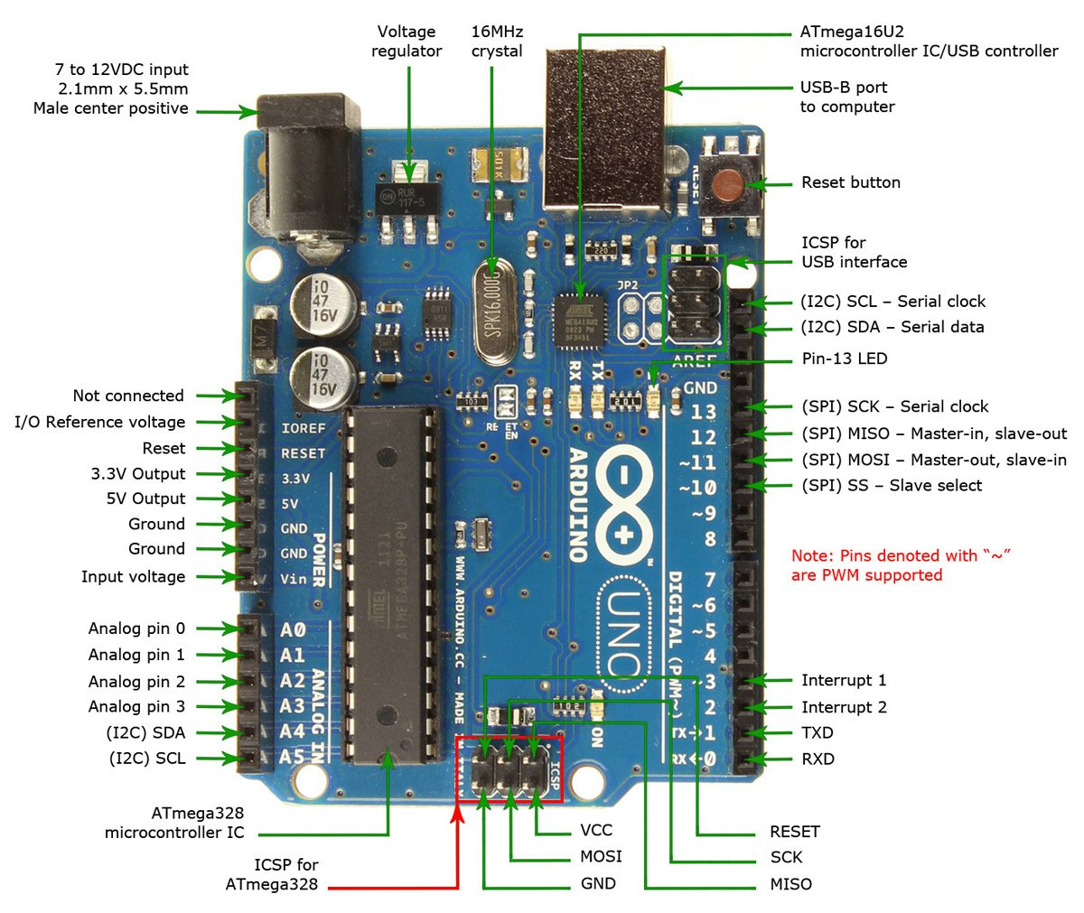

**3.2.3 Communication**

Arduino can be used to communicate with a computer, another Arduino board or other microcontrollers. The ATmega328P microcontroller provides UART TIL (5V) serial communication which can be done using digital pin 0 (Rx) and digital pin 1 (TX). The Arduino software includes a serial monitor which allows simple textual data to be sent to and from the Arduino board. There are two RX and TX LEDs on the Arduino board which will flash when data is being transmitted via the USB-to-serial chip and USB connection to the computer (not for serial communication on pins 0 and 1). A Software Serial library allows for serial communication on any of the Uno’s digital pins. The Arduino software includes a Wire library to simplify use of the 12C bus.

**3.2 HC-05 Bluetooth Module**

HC-05 module is an easy to use Bluetooth SPP (Serial Port Protocol) module, designed for transparent wireless serial connection setup.

Serial port Bluetooth module is fully qualified Bluetooth V2.0+EDR (Enhanced Data Rate) 3Mbps Modulation with complete 2.4GHz radio transceiver and baseband. It uses CSR Bluecore 04-External single chip Bluetooth system with CMOS technology and with AFH (Adaptive Frequency Hopping Feature). It has the footprint as small as 12.7mmx27mm.Hope it will simplify your overall design/development cycle.

The **HC-05** is a very cool module which can add two-way (full-duplex) wireless functionality to your projects. You can use this module to communicate between two microcontrollers like Arduino or communicate with any device with Bluetooth functionality like a Phone or Laptop. There are many android applications that are already available which makes this process a lot easier. The module communicates with the help of USART at 9600 baud rate hence it is easy to interface with any microcontroller that supports USART. We can also configure the default values of the module by using the command mode. So if you looking for a Wireless module that could transfer data from your computer or mobile phone to microcontroller or vice versa then this module might be the right choice for you. However do not expect this module to transfer multimedia like photos or songs; you might have to look into the CSR8645 module for that.

10
HC-05 Bluetooth Module
HC-05 module is an easy to use Bluetooth SPP (Serial Port Protocol) module,
designed for transpa...

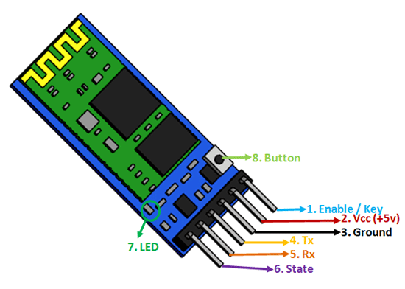

**3.2.1 Use of HC-05 Bluetooth Module**

The **HC-05** has two operating modes, one is the Data mode in which it can send and receive data from other Bluetooth devices and the other is the AT Command mode where the default device settings can be changed. We can operate the device in either of these two modes by using the key pin as explained in the pin description.

It is very easy to pair the HC-05 module with microcontrollers because it operates using the Serial Port Protocol (SPP). Simply power the module with +5V and connect the Rx pin of the module to the Tx of MCU and Tx pin of module to Rx of MCU as shown in the figure below

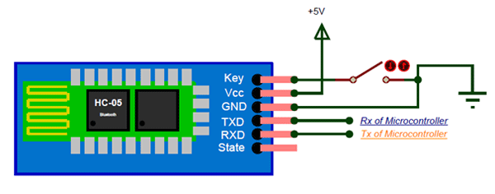

**3.2.3 Applications**

1. Wireless communication between two microcontrollers

2. Communicate with Laptop, Desktops and mobile phones

3. Data Logging application

4. Consumer applications

5. Wireless Robots

6. Home Automation

**3.2.4 HC-05 Bluetooth Module Interfacing with Arduino UNO**

HC-05 is a Bluetooth device used for wireless communication with Bluetooth enabled devices (like Smartphone). It communicates with microcontrollers using serial communication (USART). Default setting of HC-05 Bluetooth module has 3.3 V level for RX/TX and microcontroller can detect 3.3V level, so, there is no need to shift TX voltage level of HC-05 module. But we need to shift the transmit voltage level from microcontroller to RX of HC-05 module.

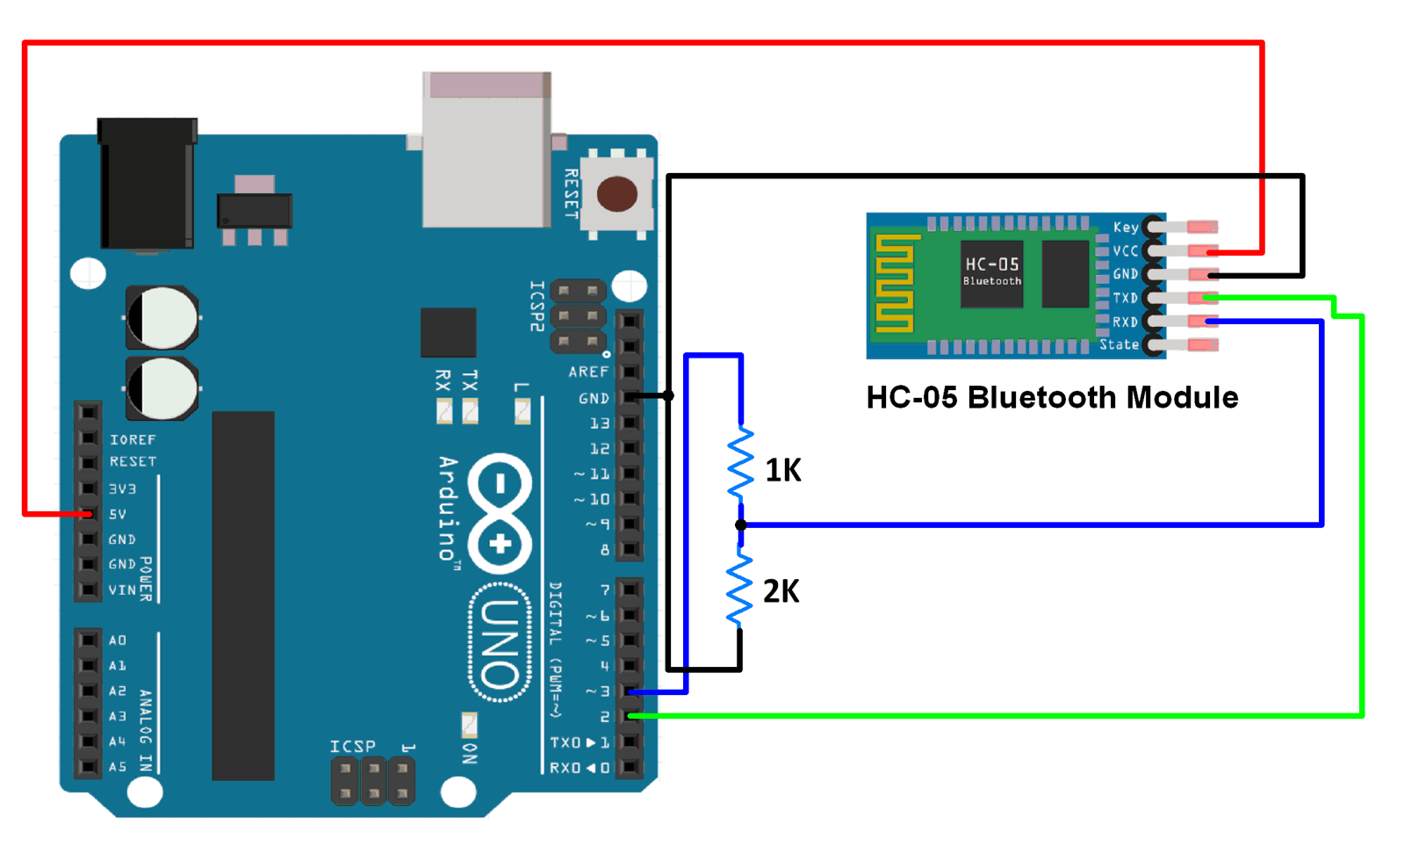

**3.3 4-Channel Relay Module**

The **four-channel relay module** contains four 5V relays and the associated switching and isolating components, which makes interfacing with a microcontroller or sensor easy with minimum components and connections. The contacts on each relay are specified for 250VAC and 30VDC and 10A in each case, as marked on the body of the relays.

**3.3.1 Understanding 5V 4-Channel Relay Module**

The four-channel relay module contains four [5V relays](https://components101.com/5v-relay-pinout-working-datasheet) and the associated switching and isolating components, which makes interfacing with a [microcontroller](https://components101.com/microcontrollers) or [sensor](https://components101.com/sensors) easy with minimum components and connections. There are two terminal blocks with six terminals each, and each block is shared by two relays. The terminals are screw type, which makes connections to mains wiring easy and changeable.

The four relays on the module are rated for 5V, which means the relay is activated when there is approximately 5V across the coil. The contacts on each relay are specified for 250VAC and 30VDC and 10A in each case, as marked on the body of the relays.

The switching [transistors](https://components101.com/transistors) act as a buffer between the relay coils that require high currents, and the inputs which don’t draw much current. They amplify the input signal so that they can drive the coils to activate the relays. The freewheeling diodes prevent voltage spikes across the transistors when the relay is turned off since the coils are an inductive load. The indicator [LEDs](https://components101.com/tags/led) glow when the coil of the respective relay is energized, indicating that the relay is active. The [optocouplers](https://components101.com/optocouplers) form an additional layer of isolation between the load being switched and the inputs. The isolation is optional and can be selected using the VCC selector jumper. The input jumper contains the main V­CC, GND, and input pins for easy connection using female jumper wires.

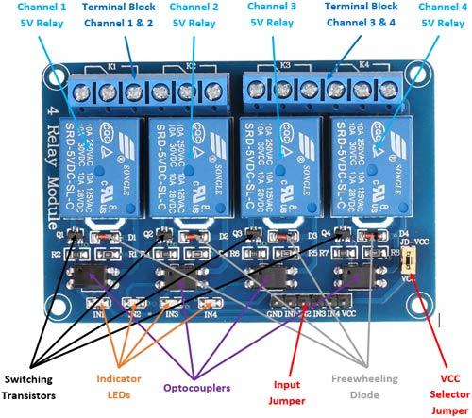

**3.3.2 Use of 4-Channel Relay Module**

The four-channel can be used to switch multiple loads at the same time since there are four relays on the same module. This is useful in creating a central hub from where multiple remote loads can be powered. It is useful for tasks like home automation where the module can be placed in the main switchboard and can be connected to loads in other parts of the house and can be controlled from a central location using a microcontroller

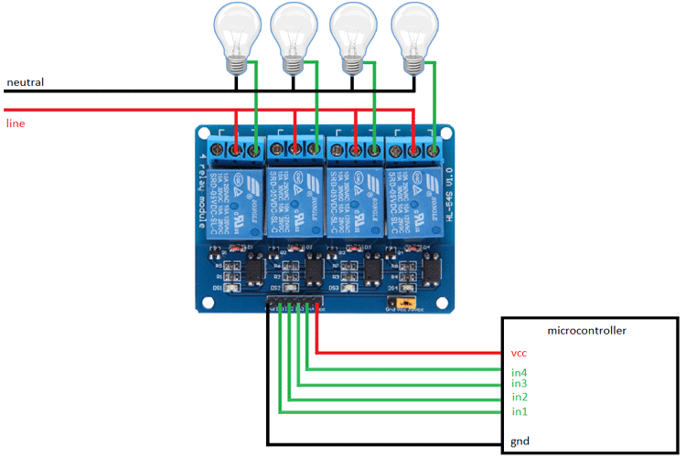

In this diagram, four separate loads (represented by lightbulbs) have been connected to the NO terminals of the relay. The live wire has been connected to the common terminal of each relay. When the relays are activated, the load is connected to the live wire and is powered. This setup can be reversed by connecting the load to the NC terminal that keeps it powered on till the relay is activated.

**3.3.3 Pin Description**

**Input:**

VCC: Positive supply voltage

GND: Ground

IN1—IN4: Relay control port

**Output:**

Connect a load, DC 30V/10A, AC 250V/10A

**3.3.4 Features**

1. Size: 75mm (Length) * 55mm (Width) * 19.3mm (Height)
2. Weight: 61g
3. PCB Color: Blue
4. There are four fixed screw holes at each corner of the board, easy for install and fix. The diameter of the hole is 3.1mm
5. High quality Single relay is used with single pole double throw, a common terminal, a normally open terminal, and a normally closed terminal
6. Optical coupling isolation, good anti-interference.
7. Closed at low level with indicator on, released at high level with indicator off
8. VCC is system power source, and JD_VCC is relay power source. Ship 5V relay by default. Plug jumper cap to use
9. The maximum output of the relay: DC 30V/10A, AC 250V/10A

**Chapter 4**

**Implementation**

**4.1 Program Code**

**Sketch for Displaying Data Received Via Bluetooth On Serial Monitor**

String inputs;

#define relay1 2 //Connect relay1 to pin 9

#define relay2 3 //Connect relay2 to pin 8

#define relay3 4 //Connect relay3 to pin 7

#define relay4 5 //Connect relay4 to pin 6

#define relay5 6 //Connect relay5 to pin 5

#define relay6 7 //Connect relay6 to pin 4

#define relay7 8 //Connect relay7 to pin 3

#define relay8 9 //Connect relay8 to pin 2

void setup()

{

Serial.begin(9600); //Set rate for communicating with phone

pinMode(relay1, OUTPUT); //Set relay1 as an output

pinMode(relay2, OUTPUT); //Set relay2 as an output

pinMode(relay3, OUTPUT); //Set relay1 as an output

pinMode(relay4, OUTPUT); //Set relay2 as an output

pinMode(relay5, OUTPUT); //Set relay1 as an output

pinMode(relay6, OUTPUT); //Set relay2 as an output

pinMode(relay7, OUTPUT); //Set relay1 as an output

pinMode(relay8, OUTPUT); //Set relay2 as an output

digitalWrite(relay1, HIGH); //Switch relay1 off

digitalWrite(relay2, HIGH); //Swtich relay2 off

digitalWrite(relay3, HIGH); //Switch relay1 off

digitalWrite(relay4, HIGH); //Swtich relay2 off

digitalWrite(relay5, HIGH); //Switch relay1 off

digitalWrite(relay6, HIGH); //Swtich relay2 off

digitalWrite(relay7, HIGH); //Switch relay1 off

digitalWrite(relay8, HIGH); //Swtich relay2 off

}

void loop()

{

while(Serial.available()) //Check if there are available bytes to read

{

delay(10); //Delay to make it stable

char c = Serial.read(); //Conduct a serial read

if (c == '#'){

break; //Stop the loop once # is detected after a word

}

inputs += c; //Means inputs = inputs + c

}

if (inputs.length() >0)

{

Serial.println(inputs);

if(inputs == "A")

{

digitalWrite(relay1, LOW);

}

else if(inputs == "a")

{

digitalWrite(relay1, HIGH);

}

else if(inputs == "B")

{

digitalWrite(relay2, LOW);

}

else if(inputs == "b")

{

digitalWrite(relay2, HIGH);

}

else if(inputs == "C")

{

digitalWrite(relay3, LOW);

}

else if(inputs == "c")

{

digitalWrite(relay3, HIGH);

}

else if(inputs == "D")

{

digitalWrite(relay4, LOW);

}

else if(inputs == "d")

{

digitalWrite(relay4, HIGH);

}

else if(inputs == "E")

{

digitalWrite(relay5, LOW);

}

else if(inputs == "e")

{

digitalWrite(relay5, HIGH);

}

else if(inputs == "F")

{

digitalWrite(relay6, LOW);

}

else if(inputs == "f")

{

digitalWrite(relay6, HIGH);

}

else if(inputs == "G")

{

digitalWrite(relay7, LOW);

}

else if(inputs == "g")

{

digitalWrite(relay7, HIGH);

}

else if(inputs == "H")

{

digitalWrite(relay8, LOW);

}

else if(inputs == "h")

{

digitalWrite(relay8, HIGH);

}

inputs="";

}

}

**4.2 Design And Implementation**

A low cost and efficient smart home system is presented in our design. This system has two main modules: the hardware interface module and the software communication module. At the heart of this system is the Arduino Uno which is also capable of functioning as a micro web server and the interface for all the hardware modules. All communication and controls in this system pass through the microcontroller.

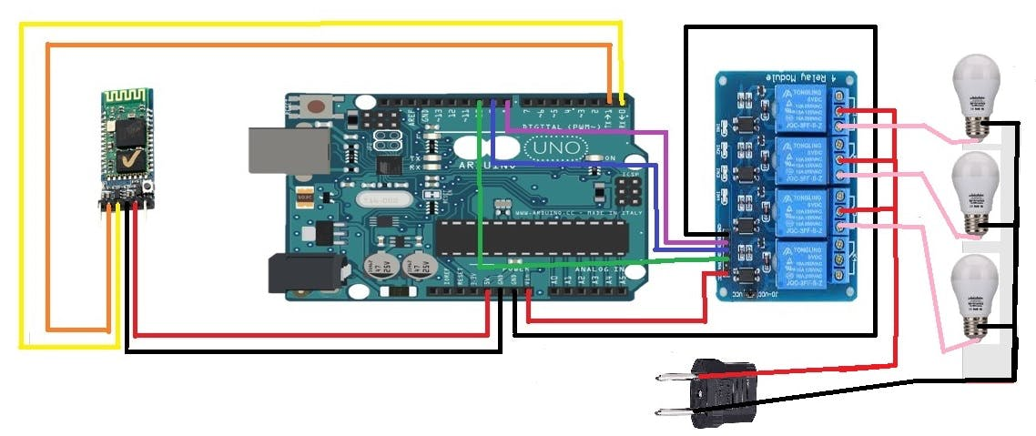

**Circuit Diagram**

31
CIRCUIT DAIGRAM
5.1 Technical Specification for this project
1) A smartphone or an Android mobile which should have the...

**Chapter 5**

**Pros And Cons of Home Automation**

**Pros Of Home Automation**

1. **Security**

Tap your finger to turn on the lights when you get home so you worried about what’s hiding in the shadows, or in your pathways. Or automate to turn on when you aren’t home to look like you are to ward off potential robbers. Door locks are another automated home product that can increase your security.

1. **Energy Efficiency**

Increase your home’s energy efficiency by remotely powering off systems and appliances when they aren’t in use. In addition to the standard home automation products that give you active control, some products actively monitor systems and arm the homeowner with knowledge, insight and guidance to achieve greater control and energy efficiency.

1. **Saving**

Home Automation literally pays off. When you are able to use home systems and appliances only when needed, the savings will be apparent in the first utility bill. No more wasting money on lights left on when you aren’t home, or spending money on gas to drive home because you forgot to lock the door. Monetary saving are apparent, but you’ll also be saving time. No wasted trips home, no running through the house turning everything off, no time spent worrying about what was or wasn’t turned off.

1. **Convenience**

Don’t you hate having to rely on neighbours to watch your house when you’re gone? With home automation, convenient control of your home is at your fingertips. You don’t have to trust someone else with your most valued possessions.

1. **Comfort**

Ever leave for work in the morning when it was comfortable 680 outside only to come home to a sweltering house because the temperature shot up to 900? Connected home products like the SensiTM Wi-Fi Thermostats let you conveniently adjust your home temperature from the mobile app so your family is always comfortable.

**Cons Of Home Automation**

1. **Cost of Intelligence**

Installing state-of-the-art features inside a home results in a higher price tag for the property. The cost of an intelligent home that makes our lives convenient is high because some of the technology is relatively new. The cost of living expenses such as utilities, maintenance and repair of the technology can be expensive as well.

1. **Technology Learning Curve**

Owning a smart home means having to learn how to use your home. Unlike traditional homes, smart home technology requires you to adapt to the innovations within your living area such as security systems, air units and a remote that controls your entire house. For the technology-savvy family, the smart home will help achieve convenience faster, but for others, it will take reading manuals and learning how-to before the benefits of convenience pay off.

1. **Video Surveillance**

Video surveillance can be a wonderful tool in heightening security and deterring crime, but when the technology falls into the wrong hands, issues of privacy can occur. Security sensors within the doors and walls of a smart home use wireless technology to transfer signals to a central control unit that notifies emergency officials of any foreign activity.

**Chapter 6**

**Application Of This Project**

1. Using this project, we can turn on or off appliances remotely i.e. using a phone or tablet.
2. The project can be further expanded to a smart home automation system by including some sensors like light sensors, temperature sensors, safety sensors etc, and automatically adjust different parameters like room lighting, air conditioning (room temperature), door locks etc, and transmit the information to our phone.
3. Additionally, we can connect to internet and control the home from remote location over internet and also monitor the safety. Further Development of the Project.
4. Arduino based device control using Bluetooth on Smartphone project can be enhanced to control the speed of the fan or volume of the buzzer etc.
5. Home automation and Device controlling can be done using Internet of Things-IOT technology.
6. We can replace Bluetooth by GSM modem so that we can achieve device controlling by sending SMS using GSM modem.

**Chapter 7**

**Conclusion**

The home automation system has been experimentally proven to work satisfactorily by connecting sample appliances to it and the appliances were successfully controlled from a wireless mobile device.

We learned many skills such as soldering, wiring the circuit and other tools that we use for this project and was able to work together as a team during this project.

The Bluetooth client was successfully tested on a multitude of different mobile phones from different manufactures, thus proving its portability and wide compatibility. Thus a low-cost home automation system was successfully designed, implemented and tested.